**COIT20273: Software Development Project**

**Term 1, 2021**

**Artefact Two**

**Lecturer / Tutor: Indra Seher**

**Unit Coordinator: Lily Li**

**Prepared by:**

**Bishal Budhathoki (12116421)**

**Laxman Khanal (12123129)**

**Niraj Prasad Timila (12125320)**

**Raken Shahi (12119317)**

Table of Contents

Project Brief 3

Layered architecture 3

Software Architecture: 4

Database Design: 5

Class Modelling 6

Behaviour Modelling 7

Prototype 9

Reference 15

# Project Brief

The name of our project is will job finder which is a web-based application to search and apply for the job. The main users of this application are Students and employers. Both users and employers need to sign up before using this application, whereas employers can post the jobs under three categories Software Development, Network, Business Analysis and Project Management, on the other hand students can apply for the same jobs under three main categories under their own interest.

Since it is a web-based application we are planning to use React as our platform to develop the application. The application will be based on a three-tier software application (presentation layer, business logic layer and database layer). We will use HTML, CSS, and JS to build our frontend design.

# Layered architecture

Layered architecture is one of the most used patterns in software engineering. Every layer in this architecture has their own roles and responsibility. For example, architecture layer handles user interaction with the system, business layer roles are to execute certain business rules linked with request, database layer responsible for saving data.

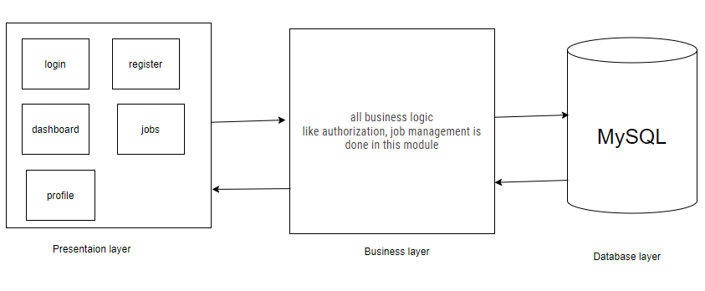*Fig 1: layered diagram*

# Software Architecture:

It basically displays the basic structure of an application and hides the major or complex implementation details. For the completion of the project, we have adapted the three-tier architecture and is made up of three “tiers” or “layers” of logical computing. The three major components are presentation, business, and database layer.  
  
Our users (admin, job seeker, job provider) will interact with the application via the user interface in the presentation tier. The business tier performs the business operations based on the request that is, it determines the core application capabilities. Database layer consists of data storage and access layer.

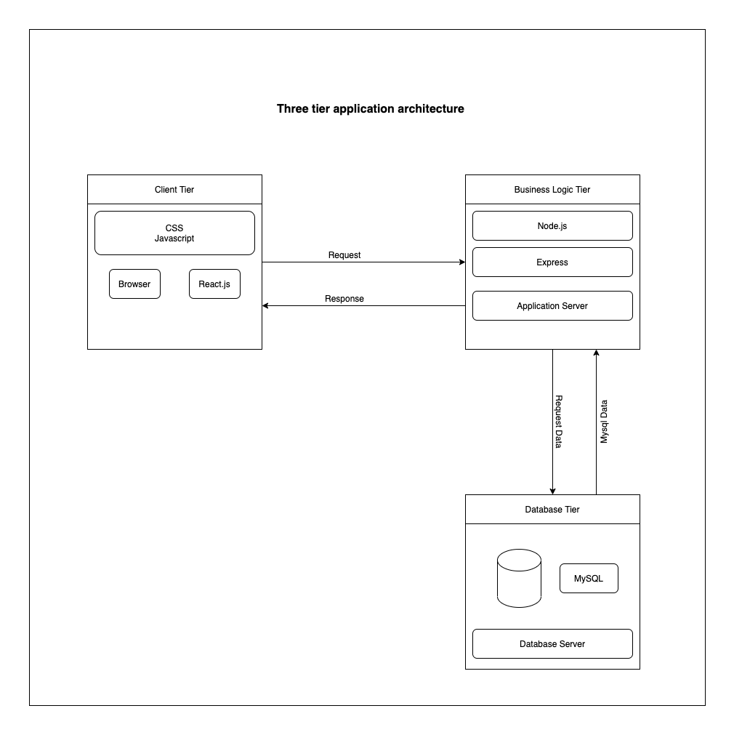

*Fig 2: Three tier application architecture.*

# Database Design:

It is a way of organising data in a way so that it matches the database model. For our project we will have various entities like User, Address, Job Post, Application, and their attributes which are shown in the below diagram.

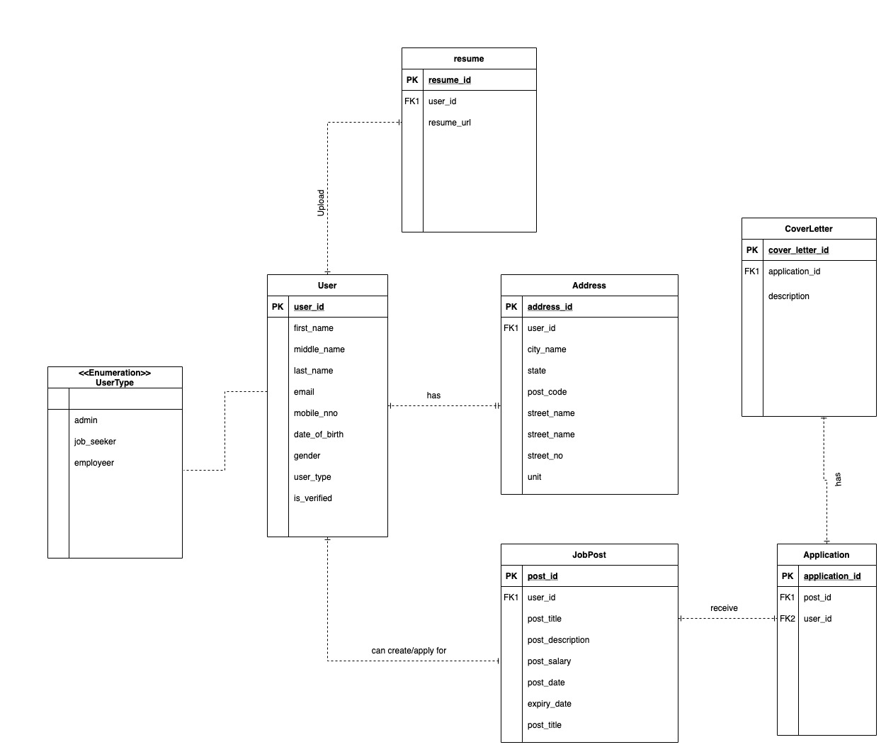

*Fig 3: Database Design*

# Class Modelling

A class diagram can be defining as one of the Unified Modelling Language which is a static structure diagram type used to depict the system’s structure by displaying attributes, classes, methods, and relationships between objects. The class diagram for WIL Job finder is shown below:

This system consists of four different users: admin, employee, job seeker, and visitor.

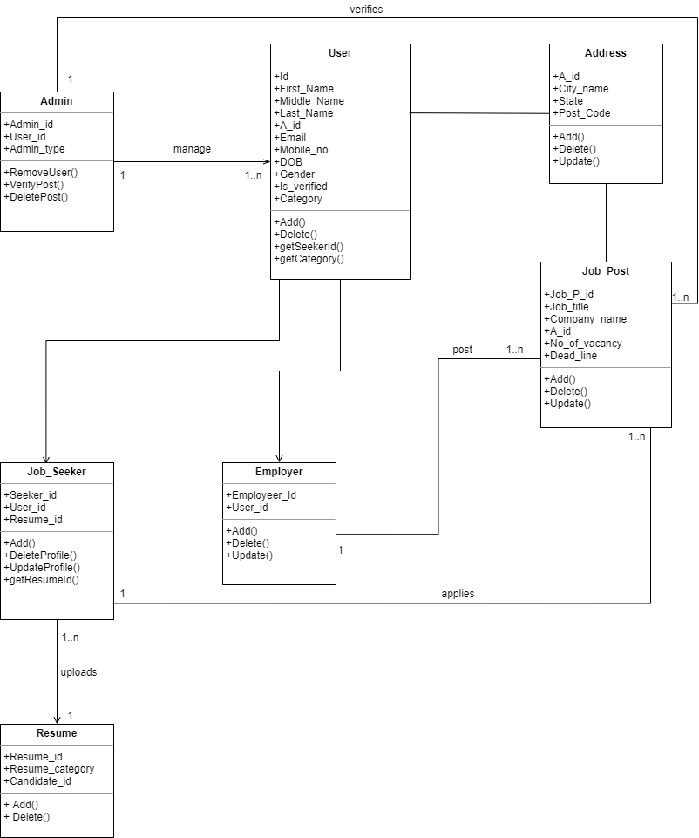

*Fig 4: Class Diagram*

# Behaviour Modelling

Behaviour modelling helps to understand the behaviour of the system and factors that affect it. It can be represented by different types such as sequence diagram and communication diagram. Here we present it with the help of sequence diagram which is as shown below:

**Sequence diagram for searching and applying for job.**

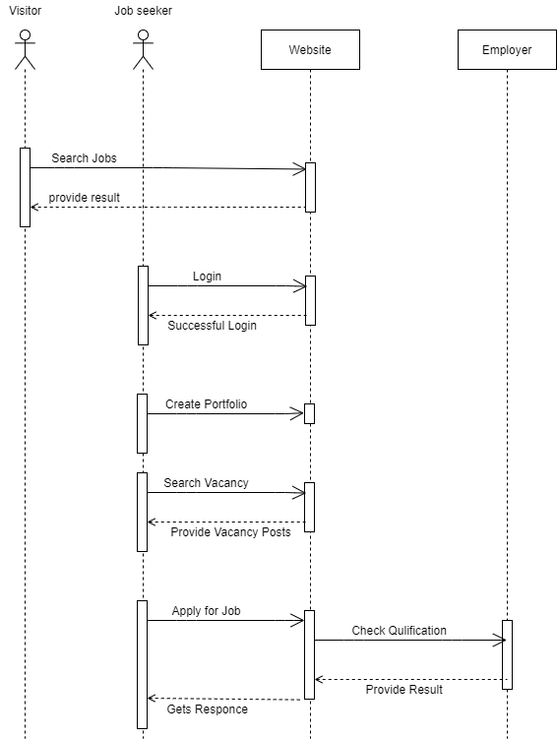

*Fig 5: Sequence diagram for searching and applying for job.*

**Sequence diagram for Posting vacancies.**

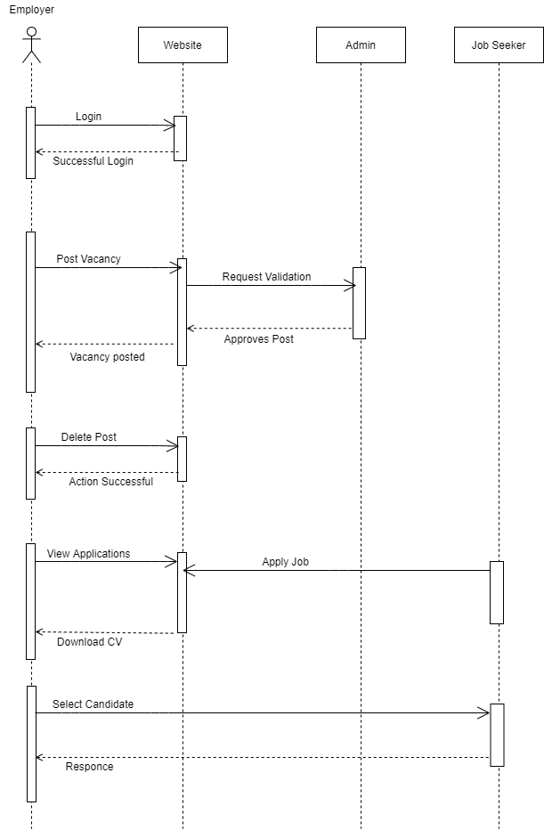

*Fig 6: Sequence diagram for posting job Vacancies.*

# Prototype

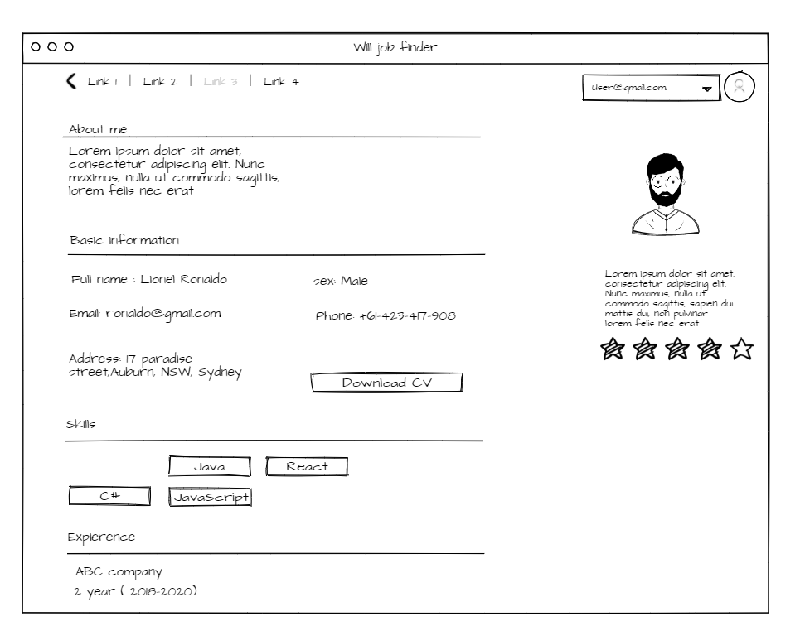

*Fig 7: Dashboard of the user*

This image shows the profile of the user including their detail on basic information, skills, experience etc.

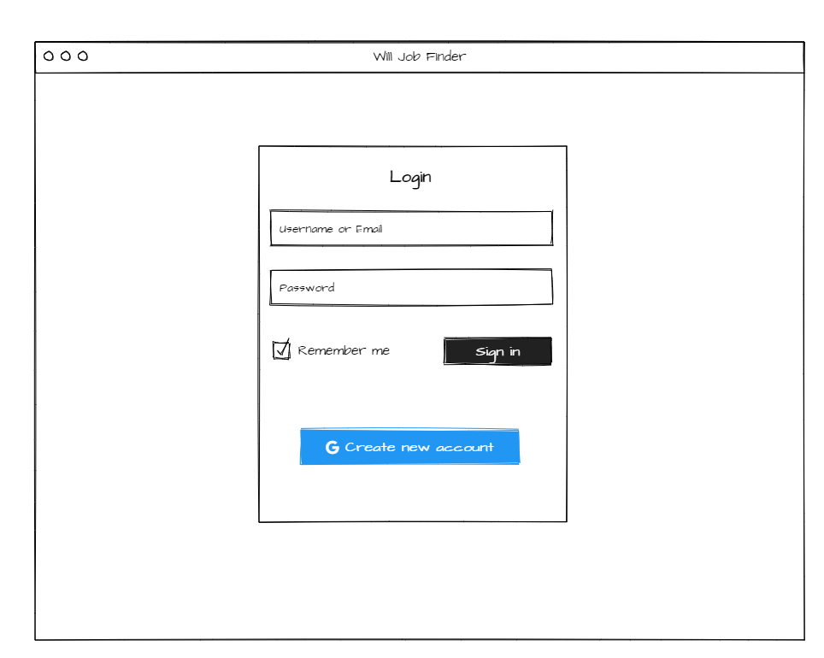

*Fig 8: Login*

The above picture is the login page of the website.

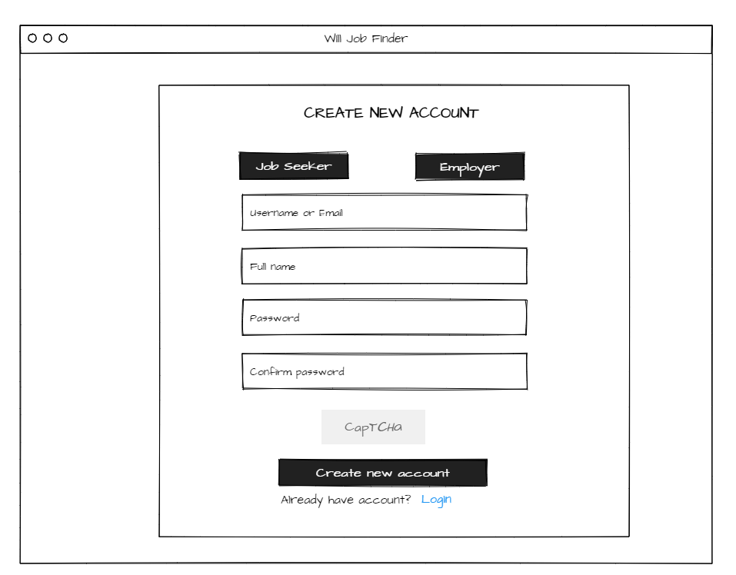

*Fig 9: Create New account*

From this page, the users will be able to register their account.

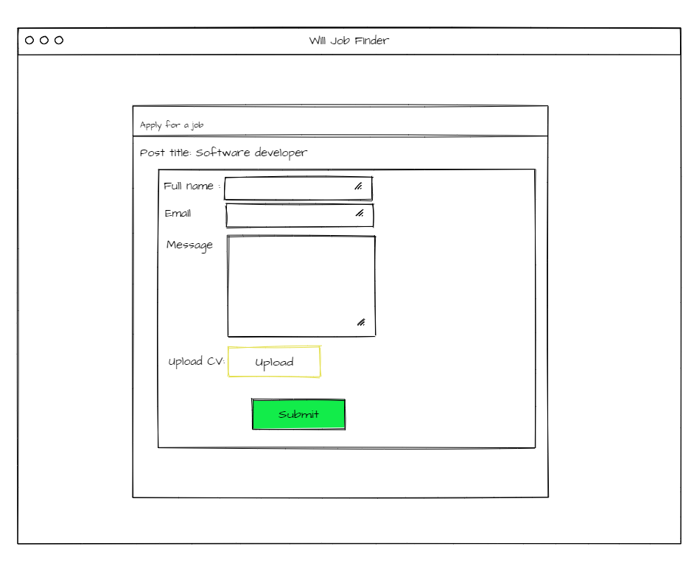

*Fig 10: Apply for job.*

On this page users can apply for the job. On top of that user can send a short message to the employer stating experience, skills and can attach CV.

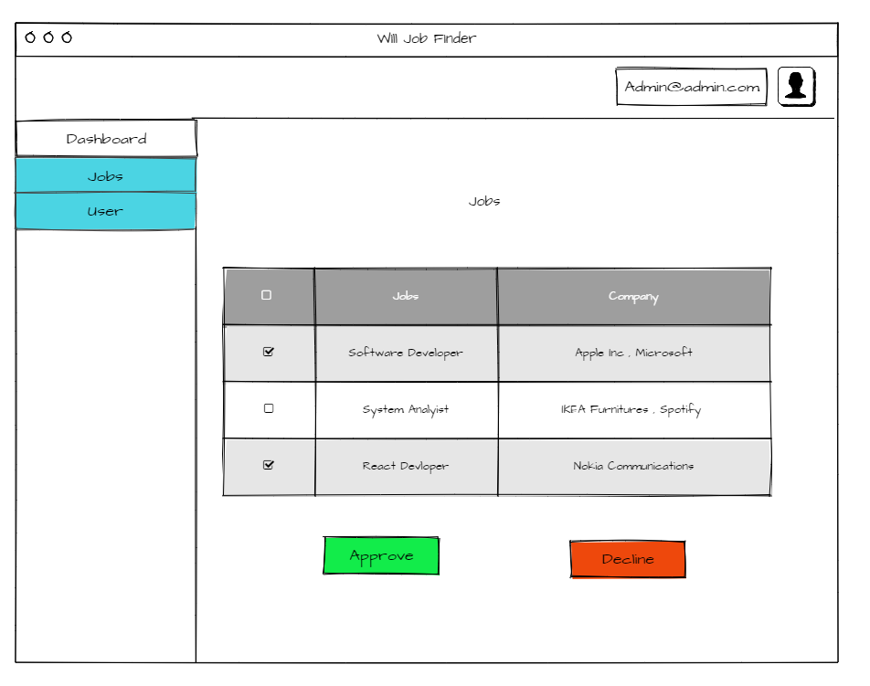

*Fig 11: Job list.*

This page is controlled by admin where admin can approve or decline the job. If admin approve the job than job will be listed in job feeds otherwise jobs are removed from the system.

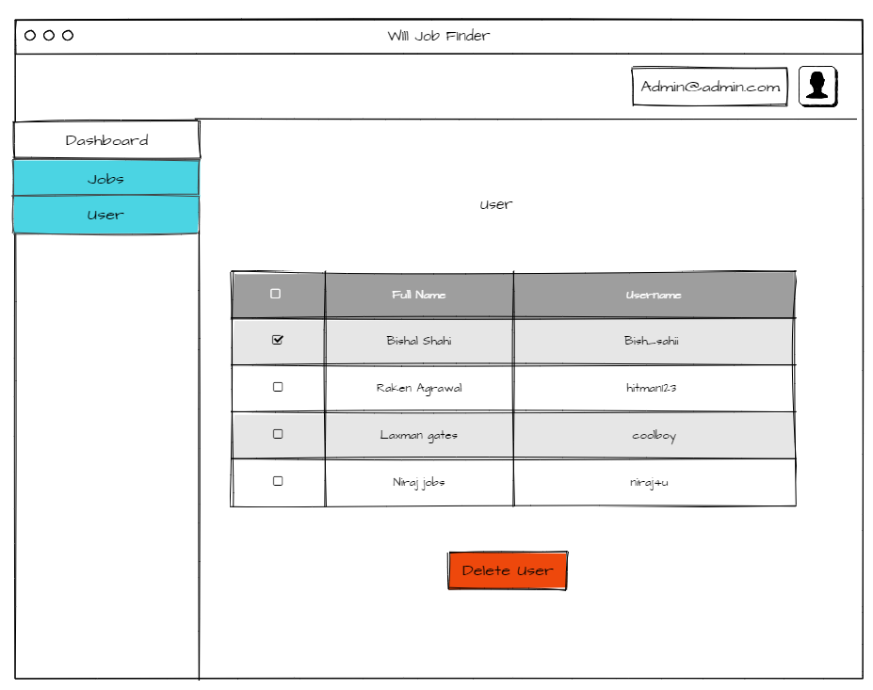

*Fig 12: User list.*

In this page admin can delete the user or can approve the new request of the user.

# Reference

*3-Tier Architecture: A Complete Overview - Logi Report* 2021. viewed 29 April 2021, <https://www.jinfonet.com/resources/bi-defined/3-tier-architecture-complete-overview/>.

*ER Diagram: Entity Relationship Diagram Model | DBMS Example* 2021. viewed 29 April 2021, https://www.guru99.com/er-diagram-tutorial-dbms.html

Hammad, M 2020, *Short note on Behavioral Model - GeeksforGeeks*. viewed 20 April 2021, <https://www.geeksforgeeks.org/short-note-on-behavioral-model/.4>

Richards, M 2018, Software Architecture Patterns. viewed 24 April 2021, <https://www.oreilly.com/library/view/software-architecture-patterns/9781491971437/ch01.html>.

*What is Class Diagram?* 2021. viewed 19 April 2021, https://www.visual-paradigm.com/guide/uml-unified-modeling-language/what-is-class-diagram/.

*What Is Software Architecture & Software Security Design and How Does It Work? | Synopsys* 2021. viewed 29 April 2021, https://www.synopsys.com/glossary/what-is-software-architecture.html